2.47: a) 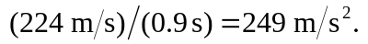 b) 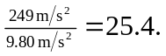 c) The most direct way to find the distance is 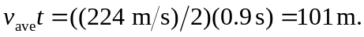
d) , so the figures are not consistent.

